Task : 1 Aim :
To Access and print the element at a given index in an array using java.

Algorithms :
Start
- Input the array (list of elements).
- Input the index (position of the element you want to access).
- Check validity of index:
If index < 0 OR index >= array length → print "Invalid index". Else → continue.
- Access the element at the given index.
- Print the element.
- End.

Program :
public class AccessArrayElement { public static void main(String[] args) {
int[] numbers = {10, 20, 30, 40, 50}; int index = 2;
if (index >= 0 && index < numbers.length) {
System.out.println("Element at index " + index + " is: " + numbers[index]);
} else {
System.out.println("Invalid index! Please choose between 0 and " + (numbers.length - 1));
}
}
}

Out put :

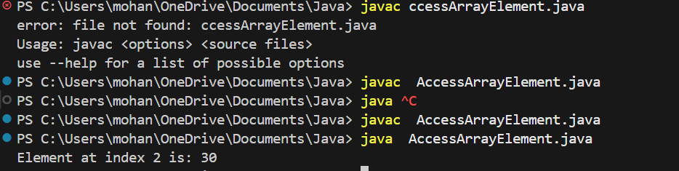

Result :

Thus the implementation of Access and print the element at a given index in an array using java was executed successfully.

Task : 2 Aim :
To Search for a given element in a sorted array using Binary Search.

Algorithms :
- Start
- Input: a sorted array A and the element key to search
- Initialize low = 0 and high = n - 1 (where n is the array size)
- Repeat while low <= high:
  - Calculate mid = (low + high) / 2
  - If A[mid] == key → return mid (element found)
  - Else if A[mid] < key → set low = mid + 1 (search right half)
  - Else → set high = mid - 1 (search left half)
- If loop ends without finding → return -1 (element not found)
- End.

Program :
public class task {
public static void main(String[] args) {
int[] numbers = {5, 15, 25, 35, 45};
int index = 3;
System.out.println("Element at index " + index + " is: " + numbers[index]);
}
}

Output :

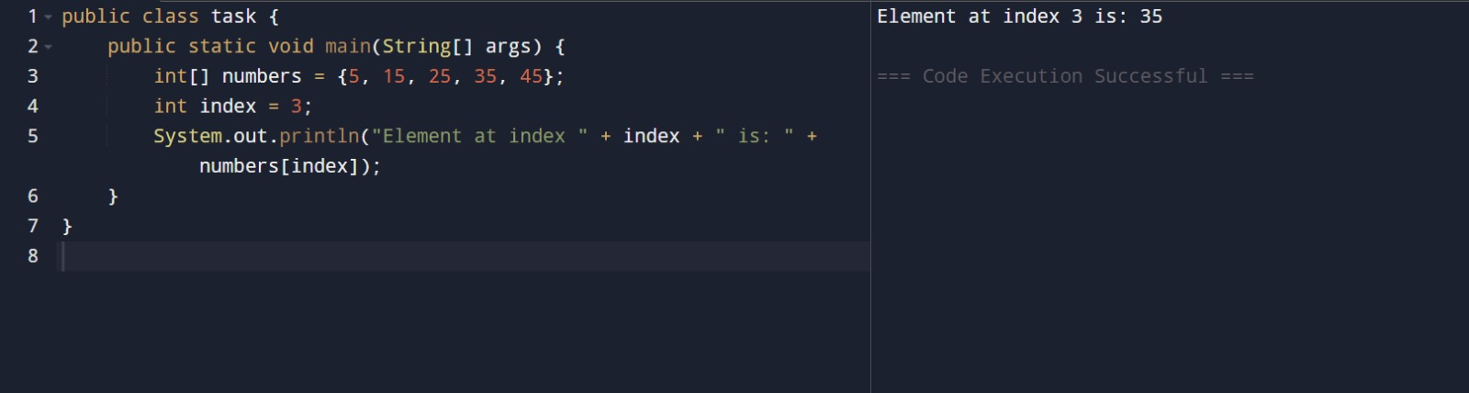

Result :
Thus the implementation of Search for a given element in a sorted array using Binary Search was executed successfully.

Task 3:

Aim :
To Find the maximum element in an array of n integers using java.

Algorithm :
- Start
- Input: an array A of size n
- Initialize: set max = A[0] (first element as the current maximum)
- Repeat for each element from index 1 to n-1:
  - If A[i] > max → update max = A[i]
- After loop ends, max holds the largest element in the array
- Output: print max
- End.

Program :

public class {
public static int binarySearch(int[] arr, int target) {
int left = 0;
int right = arr.length - 1;

while (left <= right) {
int mid = left + (right - left) / 2;

if (arr[mid] == target) {
return mid;
} else if (arr[mid] < target) {
left = mid + 1;
} else {
right = mid - 1;
}
}
return -1;
}

public static void main(String[] args) {
int[] numbers = {2, 4, 6, 8, 10, 12, 14};
int target = 10;

int result = binarySearch(numbers, target);

if (result != -1) {
System.out.println("Element found at index: " + result);
} else {
System.out.println("Element not found in the array.");
}
}
}

Output :

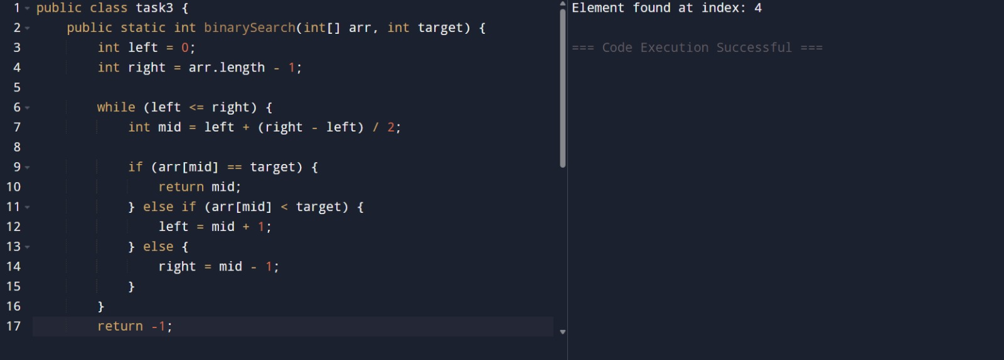

Result :
Thus the implementation Find the maximum element in an array of n integers using java was executed successfully.

Task 4 :

Aim :
To Given an array of integers and a positive integer K, write a program to find:The Kth smallest element using java.

Algorithm :
- Start
- Input:
  - An array A of size n
  - A positive integer K (where 1 ≤ K ≤ n)
- Sort the array A in ascending order
- Access the element at position K-1 (since arrays are usually 0-indexed)
- Output: print the element as the Kth smallest
- End.

Program :

public class task4 {
public static void main(String[] args) {
int[] numbers = {12, 88, 34, 6, 59, 41};
int max = numbers[0];

for (int i = 1; i < numbers.length; i++) {
if (numbers[i] > max) {
max = numbers[i];
}
}

System.out.println("Maximum element in the array is: " + max);
}
}

Output :

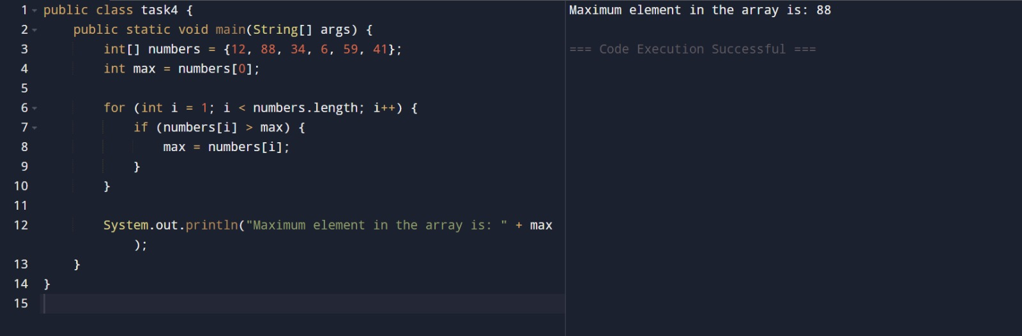

Result :
Thus the implementation of Given an array of integers and a positive integer K, write a program to find:The Kth smallest element using java was executed successfully.

Task 5 :

Aim :
To Print all possible pairs of elements from an array of size n using java.

Algorithm :
- Start
- Input: an array A of size n
- Repeat for each element A[i] from index 0 to n-1:
  - For each element A[j] from index i+1 to n-1:
  - Print the pair (A[i], A[j])
- End.

Program :

import java.util.Arrays;

class task5 {
public static int kthSmallest(int[] arr, int k) {
Arrays.sort(arr);
return arr[k - 1];
}

public static void main(String[] args) {
int[] numbers = {20, 4, 15, 8, 10};
int k = 3;

int result = kthSmallest(numbers, k);
System.out.println("Kth smallest element is: " + result);
}
}

Output :

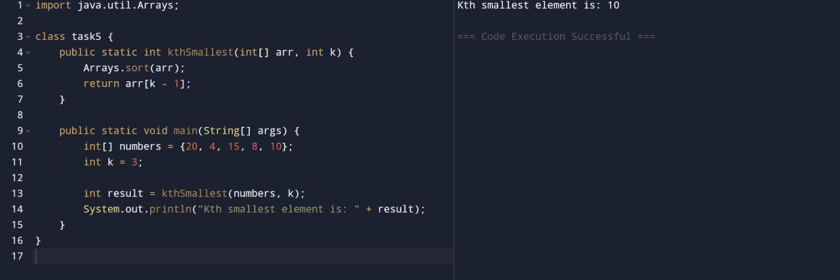

Result :
Thus the implementation Print all possible pairs of elements from an array of size n using java was executed successfully.

Task 6 : Aim :
To perform the program that calculates the sum of digits of a given integer, with an option to compute either the sum of even digits or the sum of odd digits based on user choice.

Algorithm :
- Start
- Input:
  - An integer num
  - An option opt (either "even" or "odd")
- Initialize: sum = 0
- Set a temporary variable temp = num
- Repeat while temp > 0:
  - Extract the last digit → digit = temp % 10
  - If opt = "even" and digit % 2 == 0 → add digit to sum
  - Else if opt = "odd" and digit % 2 != 0 → add digit to sum
  - Remove the last digit → temp = temp / 10
- After loop ends, sum contains the required digit sum
- Output: print "Sum of even/odd digits = sum"
- End

Program :

public class task6 {
public static void main(String[] args) {
int[] arr = {5, 10, 15};

for (int i = 0; i < arr.length; i++) {
for (int j = i + 1; j < arr.length; j++) {
System.out.println("(" + arr[i] + "," + arr[j] + ")");
}
}
}
}

Output :
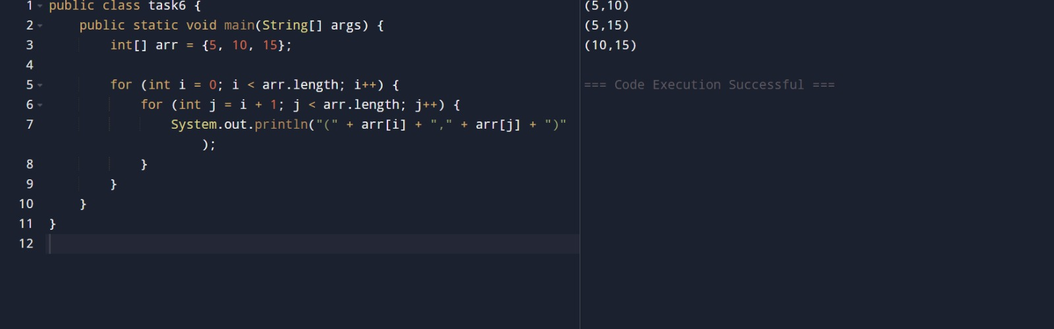

Result :
Thus the implementation calculates the sum of digits of a given integer, with an option to compute either the sum of even digits or the sum of odd digits based on user choice was executed successfully.

Task 7:
Aim :
To implement the Nth Fibonacci using java.

Algorithm :
- Start
- Input: an integer n (the position of the Fibonacci number to find)
- Check base cases:
  - If n == 1 → return 0
  - If n == 2 → return 1
- Initialize variables:
  - a = 0 (first Fibonacci number)
  - b = 1 (second Fibonacci number)
  - c = 0 (temporary variable for next Fibonacci number)
- Repeat from i = 3 to n:
  - Compute c = a + b
  - Update a = b
  - Update b = c
- After loop ends, b holds the Nth Fibonacci number
- Return b
- END.

Program :

public class UserMainCode {
public static long nthFibonacci(int input1) { if(input1 == 1) return 0;
if(input1 == 2) return 1; long a = 0, b = 1, c = 0;
for(int i = 3; i <= input1; i++) { c = a + b;
a = b;
b = c;
}
return b;
}
public static void main(String[] args) { int n = 1; System.out.println(nthFibonacci(n));
}
}

Output :
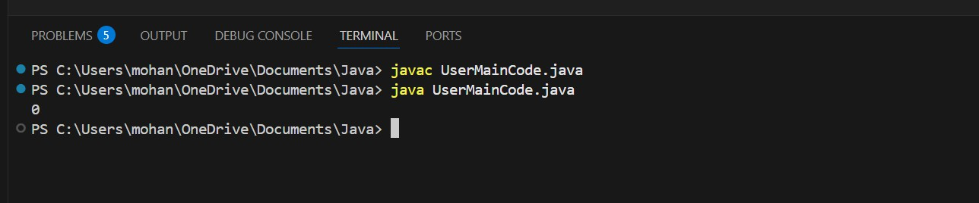

Result :
Thus the implementation Nth Fibonacci using java was executed successfully.

Task 8 :
Aim :
To implement the isPalindrome Number using java.

Algorithm :
- Start
- Input: an integer n
- Store original number → original = n
- Initialize → reverse = 0
- Repeat while n > 0:
  - Extract last digit → digit = n % 10
  - Update reverse → reverse = reverse * 10 + digit
  - Remove last digit → n = n / 10
- After loop ends:
  - If original == reverse → return 2 (number is palindrome)
  - Else → return 1 (number is not palindrome)
- Output: print result
- End.

Program :
import java.util.*;

class UserMainCode
{
public int isPalinNum(int input1){ int original = input1;
int reverse = 0; while (input1 > 0) {
int digit = input1 % 10; reverse = reverse * 10 + digit; input1 = input1 / 10;
}
if (original == reverse) return 2;
else
return 1;
}
public static void main(String[] args) { Scanner sc = new Scanner(System.in); int n = sc.nextInt();

UserMainCode obj = new UserMainCode(); int result = obj.isPalinNum(n); System.out.println(result);
}
}

Output :
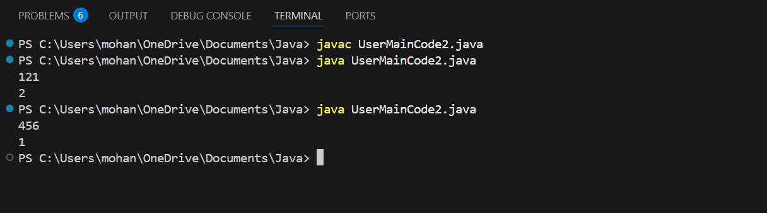

Result :
Thus the implementation isPalindrome Number using java was executed successfully.

Task 9 :

Aim :
To implement Sum of last digit of two given numbers using java .

Algorithm :
- Start
- Read two integers input1 and input2
- If input1 is negative, convert it to positive
- If input2 is negative, convert it to positive
- Find the last digit of input1 using input1 % 10
- Find the last digit of input2 using input2 % 10
- Add both last digits
- Return the sum
- Stop

Program :
import java.util.*; class UserMainCode
{
public int addLastDigits(int input1, int input2){ if(input1 < 0){
input1 = -input1;
}
if(input2 < 0){ input2 = -input2;
}
int lastdigit1 = input1 % 10; int lastdigit2 = input2 % 10; return lastdigit1 + lastdigit2
}
public static void main(String[] args){ Scanner sc = new Scanner(System.in); int a = sc.nextInt();
int b = sc.nextInt();

UserMainCode obj = new UserMainCode(); System.out.println(obj.addLastDigits(a, b));
}
}

Output :

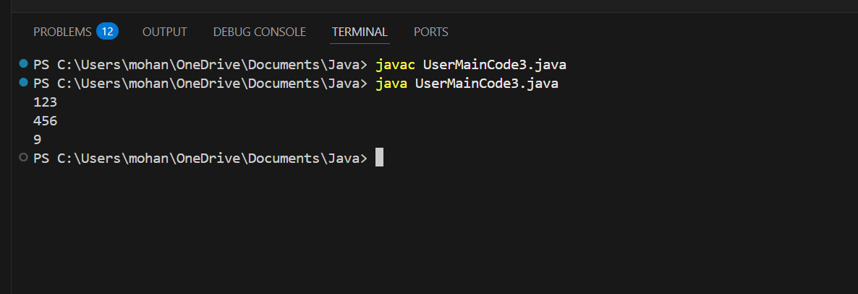

Result :
Thus the implementation Sum of last digit of two given numbers using java was executed successfully.

